Design Window for Tungsten Alloys

For the APEX Evolve Study
S. Sharafat, N. Ghoniem, R. Martinez, S. Zinkle
Jan. 2001

INTRODUCTION
The focus of this section is on the potential operating design window of tungsten alloys (W-alloys) for the APEX Evolve Study. Over the past decades, several studies have reviewed various W-alloys, such as, W-1%La₂O₃, W-5%Re, W-30Cu, W-Ni-Fe, and W-Ni-Cu [1,2]. Table 1 gives lists the pertinent physical and mechanical properties of W-alloys considered for ITER [1].
In Section 2, 3, and 4, give a summary of recrystallized W-Re alloy properties, the effects of radiation damage in refractory-alloys, and liquid coolant compatibility with refractory alloys, respectivley. Section 5, briefly overviews the high temperature creep strength limits and the effects of fabrication, alloying, and irradiation on the ductile-to-brittle-transition-temperature (DBTT) of W-alloys. The lack of irradiation data at Evolve-Study relevant high operating temperatures (~1,200°C) necessitated the use of phenomenological models to estimate the DBTT of W-alloys at elevated temperatures. We present in Section 6 the results of a recently developed model based on the Larson-Miller criteria. Section 7, summarizes the operating design window limits for W-alloys primarily based on the DBTT and the oxygen partial pressures in the coolant are suggested.

Section-1 References:
- I. Smid, et al., J. Nucl. Mater., 258-263(1998)160

Table 1: Physical and mechanical properties of some W-alloys (after Ref. [1])

SUMMARY OF RECRYSTALLIZED W-(5-10%) RE PROPERTIES

Ultimate Tensile Strength (unirradiated)
σ_{UTS}(MPa)=377.9 + 0.03207*T - 1.955x10-4*T2 + 5.13x10-8*T3 (T in ˚C) –used pure W values

Yield Strength (Unirradiated)
σ_{Y}(MPa)= 94.2 - 0.0214*T -2.12x10-6*T² -7.48x10-10*T³ (T in ˚C) –used pure W values

Elongation
e_{tot}(%)=20.8 + 0.053*T-2.18x10-5*T2 (T>500˚C) --used pure W values

Elastic constants
E_{Y} (GPa) =398 - 0.00231*T - 2.72x10⁻⁵ T² (T in ˚C) --pure W values;
W-25Re E(20˚C)=410 GPa
ν=0.279 + 1.09x10⁻⁵ T (T in ˚C)
W-25Re ν(20˚C)=0.30, G(20˚C)=159 GPa

Thermophysical properties
α_{m} (10⁻⁶/˚C)= 3.9 + 5.8x10-5*T + 5.7x10-11*T2 - 2.0x10-14*T3 (T in ˚C)
--used pure W values
C_{P} (J/kg-K) = 128+ 0.033*T - 3.4x10-6*T2 ??? (T in ˚C)
--used pure W values
K_{th} (W/m-K)~85 W/m-K (1000-2400˚C)
--conductivity decreases with increasing Re content

Recommended operating temperature limits (structural applications)
Tmin = 800˚C (due to radiation-induced increase in DBTT at low T_{irr})
Tmax = 1400˚C (Li, Pb-Li corrosion/chemical compatibility and thermal creep)

SUMMARY OF RADIATION EFFECTS IN REFRACTORY METALS
- Void swelling is not anticipated to be a lifetime-limiting issue due to the BCC structure of the high-temperature refractory alloys
- existing fission reactor data base indicate moderate swelling (<2%) for doses up to 10 dpa or higher
- effects of fusion-relevant He generation on swelling is uncertain
- swelling regimes are ~600 to 1000˚C for all 4 classes of refractory alloys

- Radiation hardening can lead to a large increase in the ductile to brittle transition temperature. The radiation hardening in BCC alloys at low temperatures (<0.3T_{M}) is typically pronounced even for doses of ~1 dpa. The amount of radiation hardening typically decreases rapidly with irradiation temperature above 0.3T_{M}, and radiation-induced increases in the DBTT may be anticipated to be acceptable at temperatures above ~0.3 T_{M} (although experimental verification is needed).

- The Group Vb alloys (V, Nb, Ta) exhibit better ductility before and after irradiation compared to Mo, W
- very limited mechanical properties data base on irradiated Nb, Ta alloys (qualitative trends can be inferred from the larger database on irradiated V alloys)
- a moderate mechanical properties data base exists for irradiated Mo alloys (but at relatively low irradiation temperatures); the irradiated W database is very limited

- Very limited or no fracture toughness/Charpy impact data exist on irradiated high temperature refractory alloys:
- “tensile DBTT” of Mo, W alloys increases to very high values even for low dose irradiations at moderate temperatures (e.g., 600˚C after ~1 dpa irradiation at 300˚C for W, W-10Re)

- Radiation-enhanced recrystallization and/or radiation creep effects need to be investigated.

W and W Alloys: P/M or CVD W, W-1% La₂O₃, W-Mo-Y (alloy W-13I)
- Tensile elongation ~0 for T_{irr}= 400, 500˚C, 0.5-1.5x10²⁶ n/m², <2 dpa (Steichen 1976, Wiffen 1984, Gorynin et al 1992); irradiations at 700˚C are in progress

- Un-notched bend bar DBTT>900˚C for W, W-10%Re irradiated at 300˚C, 0.5x10²⁶ n/m², (~1 dpa); most rapid embrittlement observed for W-10%Re (Krautwasser et al 1990)

⇒ Estimated minimum operating temperature >800˚C, based on DBTT considerations (scaling from Mo alloy data base)

COOLANT/STRUCTURE CHEMICAL COMPATIBILITY

Chemical Compatibility of High Temperature Refractory Alloys with Liquid Metals and Flibe:

- In general, the refractory alloys have very good compatibility with the liquid metals and salts of interest for fusion applications
- Impurity pickup is the key engineering issue

- Li chemical compatibility data base:
T-111 (Ta-8W-2Hf) data up to 1370˚C (good compatibility; static and circulating loops)
Nb-1Zr data up to 1000˚C (good compatibility; static and circulating loops)
W alloys up to 1370˚C (attack observed at >1540˚C)
Mo alloys (TZM) up to 1370˚C (attack observed at >1540˚C)

- Chemical compatibility data base for Flibe
(Generally good compatibility with proposed structural metals)

The W/Li compatibility limit of ~1370°C used in Table 1, are mainly based on a series of tests by J.A. DeMastry (Battelle-Columbus labs) performed in the mid-1960s. He observed good compatibility during 1000 h isothermal capsule tests at 1370°C, but corrosion/ dissolution during exposure at 1540 and 1650°C. Since dissolved tungsten was detected during post-exposure chemical analysis of the lithium, it seems unlikely that tungsten would be compatible with lithium for long-term (>>1000 h) operation at temperatures above 1400°C. On the other hand, some lithium heat pipe tests have found that W/Li was satisfactory for medium-term operation up to 1600°C. Mixed results on W/Li corrosion have been obtained in several other studies at temperatures >1400°C.
The temperature limits for low-stress conditions such as EVOLVE can be considerably higher than the reference temperature limits summarized in the APEX Table 1.
Table 2: Maximum temperatures of structural alloys (bare walls) in contact with high-purity liquid coolants, based on a 5 µm/yr corrosion limit
 | Li | Pb-17 Li | Flibe
F/M steel | 550-600°C [1,2,3] | 450°C [1,2,9 ] | 700°C ?  304/316 st. steel [14]
V alloy | 600-700°C [1,4,5] | ~650°C [1,10] | ?
Nb alloy | >1300°C [6,7] | >600°C [10]  (>1000°C in Pb) [11] | >800°C [15]
Ta alloy | >1370°C [6,7] | >600°C [10]  (>1000°C in Pb) [11] | ?
Mo | >1370°C [6,7] | >600°C [10] | >1100°C? [16,17]
W | >1370°C [6,7] | >600°C [10] | >900°C? [16]
SiC | ~550°C ? [8] | >800°C ? [12,13] | ?

Table 2 References:
1. S. Malang and R. Mattas, Fus. Eng. Des. 27 (1995) 399.
2. O.K. Chopra and D.L. Smith, J. Nucl. Mater. 155-157 (1988) 715.
3. P.F. Tortorelli, J. Nucl. Mater. 155-157 (1988) 722.
4. K. Natesan et al., Fus. Eng. Des. 27 (1995) 457.
5. O.K. Chopra and D.L. Smith, J. Nucl. Mater. 155-157 (1988) 683.
6. J.H. Devan et al., Proc. Symp. on Refractory Alloy Technology for Space Nuclear Power Applications, CONF-8308130 (1984) p. 34.
7. J.R. DiStefano, J. Mater. Eng. 11 (1989) 215.
8. D.R. Curran and M.F. Amateau, Am. Ceram. Soc. Bulletin 65, 10 (1986) 1419.
9. M. Broc et al., J. Nucl. Mater. 155-157 (1988) 710.
10. H. Feuerstein et al., J. Nucl. Mater. 233-237 (1996) 1383.
11. H. Shimotake et al., Trans. ANS 10 (1967) 141.
12. P. Hubberstey and T. Sample, J. Nucl. Mater. 248 (1997) 140.
13. J.S. Tulenko and G. Schoessow, Trans. ANS 75 (1996) 72-73
14. J.R. DiStefano, ORNL/TM-12925/R1 (1995).
15. W.D. Manley, Prog. Nucl. Energy, Series IV, 2 (1960) 164.
16. Y. Desai et al., Journal of Metals 40, 7 (1988) A63.
17. J.W. Koger and A.P. Litman, ORNL/TM-2724 (1969).

- HIGH TEMPERATURE CREEP STRENGTH LIMITS
The upper and lower temperature limits for W alloys are highly uncertain, due to a lack of relevant fracture toughness data (low temperature radiation hardening) and uncertainties in the design creep strength. The upper temperature limit of 1250°C that has been suggested for the APEX EVOLVE study is based on thermal creep of recrystallized W (1% creep in 1000 h at 150 MPa; this would correspond to similar amount of creep at ~100 MPa at 10,000 h). The temperature limit of 1250°C is clearly conservative, since stress-relieved tungsten has higher creep strength. If the design stress is less than 100 MPa then much higher temperatures can be allowed. Temperatures as high as 1400°C may be acceptable for W alloys in the EVOVLE Li-cooled design. Tungsten should be compatible with Li up to at least 1370°C based on a series of tests by J.A. DeMastry (Battelle-Columbus labs) performed in the mid-1960s. Good compatibility was observed during 1000 h isothermal capsule tests at 1370°C, however, corrosion/ dissolution during exposure at 1540 and 1650°C was also witnessed. Since dissolved tungsten was detected during post-exposure chemical analysis of the lithium, it seems unlikely that tungsten would be compatible with lithium for long-term (>>1000 h) operation at temperatures above 1400 C.

Larson Miller Based High Temperature Creep Strength Limits of W-Alloys
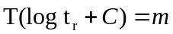The limited data base on the temperature creep strength limits of W-alloys calls for the use of Larson Miller parameters (m) , which correlate Temperature (T) with the time to failure (tr) at constant engineering stress (σ) by:

where C is a constant that depends on the alloy. Hence, if C is known for a particular alloy, one can find m in single test. From this result, one can then find the rupture times at a any temperature, as long as the same engineering stress is applied. The table below shows some typical values of the constant C for different alloys of the Larson Miller equation.

Table 3: The constant C of various alloys for the Larson Miller equation

MATERIAL | LARSON-MILLER (C)*
Various Steels | ~20
S-590 Alloys | 17
A-286 SS | 20
Nimonic 81A | 18
1-Cr-1Mo-0.25V Steel | 22
Table 3 references: M. A. Meyers, “Mechanical Behavior of Materials,” Prentice Hall, UK, 1998, p. 550.

A simplified TENSILE DESIGN STRESS can be defined as the minimum value of 1/3 of the ULTIMATE or 2/3 of the YIELD strength, which ever is smaller:
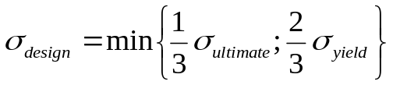

As an initial approach to determining a design stress limit the lesser of the 10-year creep stress limit and the tensile design stress limit is used. The Larson Miller based creep rupture behavior of pure W, as well as numerous W-Re and W-Re-HfC alloy has been reported in are reproduced in Figures 3-9 along with the estimated tensile design stress (σ_{design}) limits.

Figure 10 shows the Larson Miller master plot for pure W, W-4Re-0.26HfC, and W-23.4Re-0.27HfC. The Larson-Miller based design stress limits as a function of temperature of various W-alloys are compared and Fig. 11 and 12 summarizes the design stress limit calculations for all of the considered W-alloys as a function of temperature. Almost all of the alloys experience a sharp drop in strength between 1000 and 1500°C.

Below 1400°C the W-23.4Re-0.27HfC swaged and recrystallized alloy are estimated to have the highest design stress capability relative to the other alloys including pure W (see Fig 11). Above 1400°C (Fig. 12) the W-4Re-0.26HfC shows the best design stress limit with 100 MPa at (~1400°C) down to 20 MPa at (~1850°C).

Results of calculations for design stress limits at 1250°C are summarized in Table 4:

Table 4: Design stress limits of various W-alloys based on Lawson Miller calculations at 1250°C.

ALLOY | DESIGN STRESS* (MPa)
W-4Re-0.26HfC (re-crystallized) | 150
W-wrought | 160
W-1%La2O3 | 190
W-23.4Re-0.27HfC (re-crystallized) | 250
W-23.4Re-0.27HfC (swaged) | 300

*The DESIGN STRESS is defined as the lesser of the 10-year creep stress
limit and the tensile design stress limit (which is min or 1/3 ultimate or 2/3 yield).

The temperature limits for low-stress conditions such as EVOLVE can be considerably higher than the reference temperature limits summarized in previous APEX reports (interim APEX Report). Creep data for tungsten and W alloys are available at higher temperatures and lower stresses. A 150 MPa, 1000 h creep limit were cited in the APEX interim report as a typical structural material "example.” As the EVOLVE design reaches further maturity, the design stresses and temperatures can be checked against the thermal creep database. For example, the 1% creep limit for W at 1400 C (10,000 h test) is ~25-30 MPa (see Fig. 13).

- DBTT
The ductile-to-brittle transition temperature (DBTT) of unirradiated W-alloys depends primarily on the production history and the alloying elements. Figure 14 shows the range of DBTT for various W-alloys having been exposed to different thermomechanical treatments, with the as-rolled having the lowest DBTT, followed by recrystallized, and then the solution annealed alloys. However, the DBTT’s reported for the W-Re-HfC are based on tensile tests. These data cannot be used to give a reliable estimate of the fracture toughness DBTT, so it is not clear what quantitative advantage is gained with W-Re-HfC alloys.
Relative to Mo-alloys the database of neutron irradiation effects on W-alloys is much smaller. Therefore, a phenomenological approach is chosen here in order to make an educated guess of the effects of neutron irradiation and of operating temperature on the DBTT of W-alloys. Neutron irradiation produces significant hardening in the refractory metals, most of which can be anneal out at elevated temperatures. The phenomenological model is based on the assumption that Mo, TZM, and W alloys will exhibit similar rate of changes in their DBTT as a function of irradiation temperature. This approach is based on the assumption that all of these alloys will primarily experience increases in DBTT due to friction-hardening and that the onset of friction hardening and their annealing is shifted to higher temperatures for W-alloys.

Phenomenological DBTT Model
Figures 16 and 17 show the typical response of (BCC) tungsten to neutron irradiation at low temperatures: the yield strength increases with irradiation, while the ductility is reduced. The forces responsible for resisting motion of a dislocation through the crystal can be characterized as long range or short range. The total applied shear stress necessary to move the dislocation is the sum of the long-range and short-range stresses:

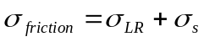

Where 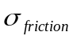is the friction stress and the subscripts LR and s represent the long-range and short-range contributions, respectively. The long-range forces arise from the repulsive interaction between the moving dislocation and the components of the dislocation network of the solid, while the short-range forces are due to obstacles that lie in the slip plane of the moving dislocation. The short-range forces are active only when the mobbing dislocation comes very close to or contacts the obstacle. The friction stress due to a dispersion of barriers depends on the average separation between the obstacles in the slip plane of the moving dislocation. The increase in short range stress (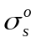)is proportional to N1/2 (N: number density of depleted zones).
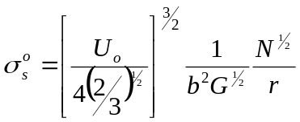

where Uo is the cutting energy for a dislocation, b the burgers vector, G the shear modulus, r the radius of obstacle and N is the number density of depleted zones. The effect of temperature on the depleted-zone hardening can be expressed by [Olender, p. 434]:

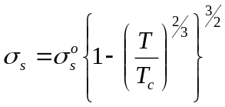
where Tc is the characteristic temperature at which the depleted zones are annealed out (about 0.44 Tm).
The saturation of radiation hardening, in the absence of destruction mechanism, is based on the time rate of change of fast-neutron induced clusters (depleted zones N):
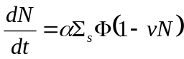

α is number of cluster zones per neutron (~1), Σs is the macroscopic scattering cross-section, v is the capture volume around a depleted zone, and F is the neutron fluence. Integration of the preceding differential equation yields:
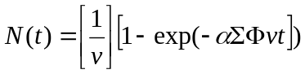
Thus in the absence of a depleted zone destruction mechanism the friction stress is proportional to N(t). However, thermal annealing is a potential mechanism for destroying depleted zones. Thermal annealing of depleted zones at high temperatures affects the zones number density, which can be expressed using the depleted-zone decay time (τ), which is a function of the temperature. Thus the number density of depleted zones can be approximated using:
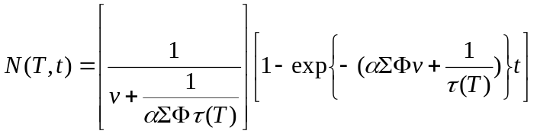

Calculated number densities of depleted zones in Mo and W based on a fluence of 2.5x10²⁶ n/m² and 5x10²⁵ n/m² are shown in Figures 18 and 21, respectively. The corresponding changes in the friction stress of these two materials are shown in Figures 19 and 22. The calculated results of changes in the DBTT for Mo are within the range of the experimental data (see Fig. 20). It is therefore assumed that the predicted changes in the DBTT of tungsten might also be representative of the actual experimental behavior. Based on these calculations, the DBTT of W alloys will not be drastically affected if the alloys are operated at temperatures above 1000°C, due to the annealing of the depleted zones. However, many other radiation induced hardening effects may influence the changes in the DBTT. Radiation hardening in metals is attributed to the production of other defects, such as:
- Point defects (vacancies & interstitials)
- Impurity atoms (atomically dispursed transmutation products).
- Small vacancy clusters (depleted zones ← considered in our model)
- Dislocation loops (faulted or unfaulted, vacancy or interstitial type)
- Dislocation lines (unfaulted loops that have joined the dislocation network of the original microsturcture)
- Cabities (voids and helium bubbles).
- Precipitates.

Except for the depleted zones (#3) the other hardening effects have not been considered in our simple phenomenological model. The results of this model are therefore to be used with caution until experimental results can disprove or verify them.
In conclusion, the use of W-alloys at elevated temperature (above 1000°C) in EVOVLE should may not result in a drastic increase in the DBTT. Therefore, it recommended that EVOVLE should use the materials parameters recommended by the APEX team (Chapter 13 in the APEX interim report).

- EVOLVE’s Base-line W-Alloy
Although the Larson Miller estimates indicated a higher design stress limit for W-Re-HfC based alloys than simple W-Re alloys, it is recommended to keep W-5Re as the "reference" tungsten alloy for the APEX Evolve design, because a reasonably full set of physical and thermomechanical properties are available for this material. The dispersion strengthened tungsten alloys may offer some improved performance, but the necessary fracture toughness measurements, etc. have not yet been performed. Based on 1999 results obtained on Mo-TiC specimens irradiated in HFIR, the TiC dispersion may not provide effective resistance to radiation embrittlement in the refractory metals.

Recommendations for Developing New W-Alloys
Recent efforts to fabricate any high-quality W-TiC specimens have not materialized, however, pending delivery of such samples tests are planned at ORNL.

Regarding the strategy for new W alloys, it is clearly a daunting task to develop an improved refractory alloy (various programs have been trying to do this off and on for ~40 years). It is likely that the un-irradiated low-temperature (<300°C) mechanical behavior of all existing tungsten alloys might be strongly influenced by impurities.

One possible development approach for tungsten alloys might focus on fabricating and determining the properties of ultra-high purity tungsten (including interstitial impurities)--can ductile tungsten be produced simply by applying modern impurity control processes or by adding appropriate mass-balanced impurity gettering agents? There is some evidence that it is possible to produce high ductility Mo alloys (at room temperature) using intragranular Zr doping. However, this approach has not yet been demonstrated the other group VI refractory metals, except for the so-called tungsten heavy alloys (W-Fe-Ni). The short synopsis of the current situation regarding W-alloys is that all of the available alloys have shortcomings, and there is no obvious development path for producing improved material.

A small, targeted research program that at least shows there is a light at the end of the tunnel would be the best strategy for developing W alloys for fusion. However, using realistic assumptions for available budgets, it will take years before an impact of this R&D will be seen. Success is not ensured even if there was a significant amount of available funding (remember that other programs have spent decades trying to develop improved W alloys). The Materials Program "B-budget" presented at the VLT meeting last week in Germantown included a moderate-sized (~270k$/yr.) task on refractory alloys.

Regarding the W alloy development issue, since we do not understand why W can be ductile with alloying, it will be futile to develop a whole series of alloys with out first directing our attention to the science issues related to the ductility (or lack thereof) of W and its alloys. Recently, W alloy research proposal have been suggested, which in essence extend the current W-Re and W-TiC alloys. However, first thorough understandings of the underlying physical mechanisms, which produce improved ductility in W-Re (and perhaps W-TiC), are needed before more complicated alloys are made.

A similar comment could be made regarding W-Fe-Ni. Once the role of Ni in the heavy alloys is understood, and then a reduced-activation substitute element can be chosen. The main problem with W-Fe-Ni alloys is that the upper operating temperature would be much lower than conventional W alloys - probably too low for use in EVOLVE. We should direct our attention to the science issues related to the ductility (or lack thereof) of W and its alloys.

As far as Evolve is concerned, we can use the properties of W-Re alloys for the time being, while an effort is made at the science front.

0
100
200
300
400
500
600
0
200
400
600
800
1000
1200
1400
1600
1800
2000
Temperature (C)
W
Ta
Cb
Mo
Mo
Ta
Nb
W
Ultimate Tensile Stress (MPa)
Tietz, 1965
Figure 1: Comparison of Tensile Behavior of Some Refractory Metals

Reference: T.E. Tietz and J.W. Wilson, Behavior and Properties of Refractory Metals, Stanford, Calif., Stanford University Press, 1965., p. 195
0
50
100
150
200
250
800
900
1000
1100
1200
1300
1400
W
Mo
Cb
Ta
Mo
Ta
Nb
W
Stress (MPa)
Temperature (C)
Tietz, 1965
Figure 2: high temperature creep strength of refractory metals (100 hour test results)

Reference: T.E. Tietz and J.W. Wilson, Behavior and Properties of Refractory Metals, Stanford, Calif., Stanford University Press, 1965, p. 195
0
20
40
60
80
100
120
140
160
180
200
0
500
1000
1500
2000
2500
Temperature (C)
1 year creep life span
3 year creep life span
10 year creep life span
2/3 yield stress
1/3 ultimate stress
Design Stress Limit
Stress (MPa)
Figure 3: Larson Miller based creep rupture of pure W (arc-melted, recrytallized)

References: Sims, “Properties of Refractory Alloys Containing Rhenium”, Trans. ASM, 52 (1960) p. 929- 941
Shin, “High Temperature Properties of Particle Strengthened W-5Re”, JOM August 1990, p. 12-15

0
100
200
300
400
500
600
700
0
500
1000
1500
2000
2500
3000
Temperature (C)
1 year creep life span
3 year creep life span
10 year creep life span
1/3 ultimate stress
design stress limit
Stress (MPa)
Figure 4: Larson Miller based creep rupture of pure W (wrought, as-cast, tested in hydrogen)

References: Tajime, “The Tensile Strength of Tungsten Wires at High Temperatures”, Hantaro Nagaoka Anniversary Volume, Tokyo (1925); and Flagella, “High Temperature Creep Rupture Behavior of Unalloyed Tungsten”, GE-NMPO, GEMP-543

0
10
20
30
40
50
60
70
80
90
100
0
500
1000
1500
2000
2500
3000
Temperature (C)
1 year creep life span
3 year creep life span
10 year creep life span
2/3 yield stress
1/3 ultimate stress
1/3 ultimate stress (W-
3Re Recrystallized, PM,
Taylor)
design stress limit
Stress (MPa)
Figure 5: Larson Miller based creep rupture of W-5Re (Arc-Melted, Recrystallized)

References: Vandervoort, “Creep Behavior of W-5Re”, Met. Trans., 1 (1970), p. 857-864;
Shin, “High Temperature Properties of Particle Strengthened W-5Re”, JOM August 1990, p. 12-15;
Taylor, “Tensile Properties of W-3%Re in a Vacuum”, J. of the Less Common Metals, 7 (1964), p. 27.
0
20
40
60
80
100
120
140
0
500
1000
1500
2000
2500
Temperature (C)
1 year creep life span
3 year creep life span
10 year creep life span
1/3 ultimate stress (W-24Re
annealed 1hr. 1982 C)
design stress limit
Stress (MPa)
Figure 6: Larson Miller based creep rupture of W-26Re and W-24Re (Arc-Melted, Recrystallized and Annealed)

References: Klopp, Refractory Metals and Alloys IV-Research and Development, Gordon-Breach, New York, 1967, p. 557;
Shin, “High Temperature Properties of Particle Strengthened W-5Re”, JOM August 1990, p. 12-15

0
20
40
60
80
100
120
140
160
180
200
0
500
1000
1500
2000
2500
Temperature (C)
1 year creep life span (W-4RE-
0.26HfC)
3 year creep life span (W-4RE-
0.26HfC)
10 year creep life span (W-
4RE-0.26HfC)
2/3 yield stress (W-3.6Re-
0.26HfC)
1/3 ultimate stress (W-3.6Re-
0.26HfC)
Design stress limit
Stress (MPa)
Figure 7: Larson Miller based creep rupture of W-4Re-0.26HfC and W-3.6Re-0.26HfC (Arc-Melted, Recrystallized)

Reference: Shin, “High Temperature Properties of Particle Strengthened W-5Re”, JOM August 1990, p. 12-15

0
200
400
600
800
1000
1200
1400
0
200
400
600
800
1000
1200
1400
1600
1800
2000
Temperature (C)
1-year life span
3-year life span
10-year life span
1/3 ultimate stress
2/3-yield stress
Design stress limit
Stress (MPa)
Figure 8: Larson Miller based creep rupture of W-23.4Re-0.27HfC along with estimated design stress limit (Arc-Melted, Swaged)

References: Klopp, “Mechanical Properties of a Tungsten 23.4%Re-0.27%HfC Alloy”, J. of the Less Common Metals, 24 (1971) p. 427-442; Shin, “High Temperature Properties of Particle Strengthened W-5Re”, JOM August 1990, p. 12-15
0
100
200
300
400
500
600
700
800
0
500
1000
1500
2000
2500
Temperature (C)
1 year creep life span
3 year creep life span
10 year creep life span
1/3 ultimate stress (annealed)
2/3 yield stress (annealed)
design stress limit
Stress (MPa)
Figure 9: Larson Miller based creep rupture of W-23.4Re-0.27HfC (Arc-Melted, Recrystallized)

References: Witzke, “Mechanical Properties of a Tungsten 23.4%Re-0.27%HfC Alloy”, J. of the Less Common Metals, 24 (1971), p. 427-442
y = -0.0069x + 419
y = -0.0216x + 1132.3
0
50
100
150
200
250
300
350
400
0
10000
20000
30000
40000
50000
60000
70000
Larson Miller Parameter
W Recrystallized
W-4Re-0.26HfC Recrystallized
W-23.4- Re-0.27HfC
Recrystallized
Linear (W-4Re-0.26HfC
Recrystallized)
Linear (W-23.4- Re-0.27HfC
Recrystallized)
Linear (W Recrystallized)
Stress (MPa)
y = -0.0017x + 107.39
Figure 10: LARSON-MILLER MASTER PLOT FOR Pure W, W-4Re-0.26HfC, W-23.4Re-0.27HfC (all Recrystallized)

0
100
200
300
400
500
600
700
800
0
500
1000
1500
2000
2500
Temperature (C)
W Recrystallized
W Wrought
W-5Re Recrystallized
W-50Mo Swaged
W-23.4Re-0.27HfC Swaged
W-23.4Re-0.27HfC Recrystallized
W-4Re-0.26HfC Recrystallized
W-26Re Recrystallized
2/3 yield stress W-1%La2O3
Stress (MPa)
Figure 11: Comparison of Design Stress Limits of W-Alloys (All Recrystallized) (30°C<T<2500°C)
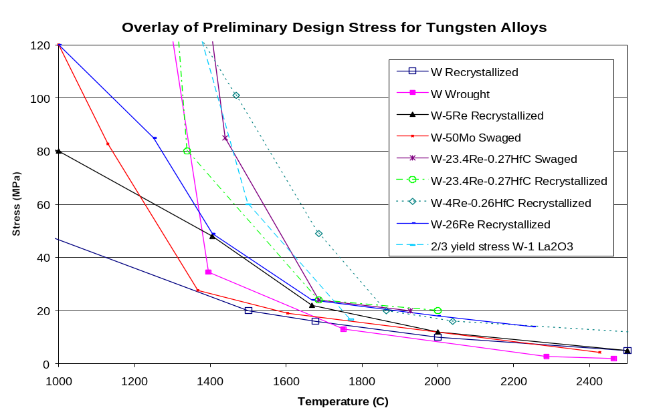
Figure 12: Comparison of High Temperature Design Stress Limits of W-Alloys (1000°C<T<2400°C)

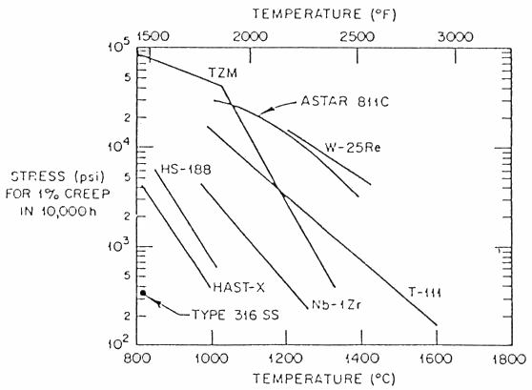
Figure 13: One-percent creep stress versus temperature of various high-temperature alloys.
W-5Re
W-HfC
W-4Re-HfC
W-26 Re
W-23.4Re-HfC
As-Rolled
Re-crystallized
SA and Aged
-200
-100
0
100
200
300
400
500

DBTT (°C)
SA &Aged
Figure 14: Approximate ductile-to-brittle transition temperatures of unirradiated W-alloys having a thermal history based on SA (solution annealed), Re-crystallized, and As-rolled.

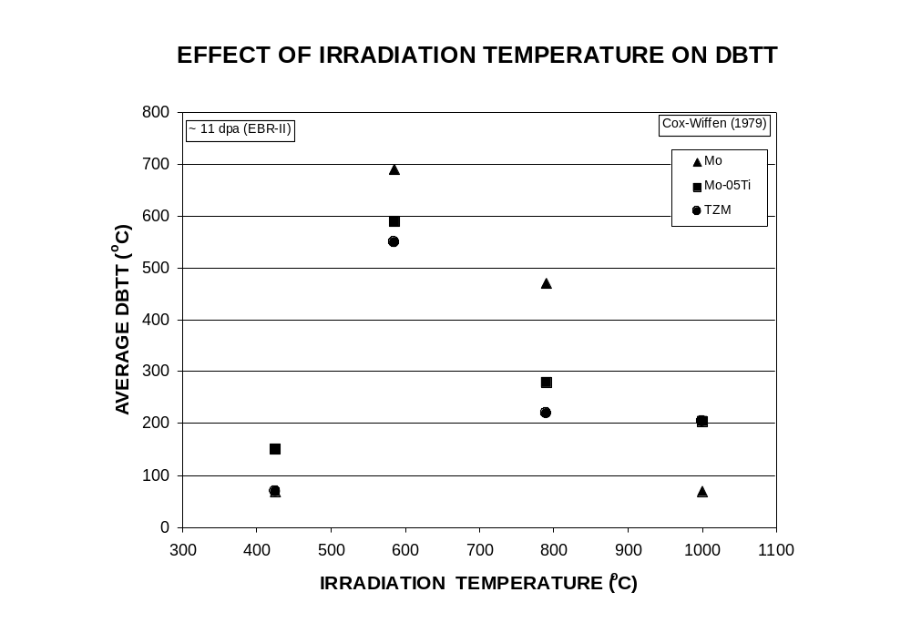
Figure 15: Effect of irradiation temperature on the DBTT of Mo and TZM alloys after 11 dpa exposure in EBR-II

Reference: B. Cox, F. Wiffen “The Ductility in Bending of Molybdenum Alloys Irradiated Between 425 and 1000°C,”
J. Nucl. Mat. 85&86(1979)901-905.
ELONGATION (%)
Figure 16: Effect of irradiation on the ductility of W as a function of test temperature for irradiated and unirradiated W.

Reference: J. M. Steichen, “Tensile Properties of Neutron Irradiated TZM and Tungsten”, J. of Nucl. Mat., 60 (1976) p. 13-19
0
5
10
15
20
25
0
200
400
600
800
1000
1200
TEMPERATURE (°C)
UNIRRADIATED

Tungsten (Steichen, 1976)
Fluence
n/cm² (E > 0.1 MeV)
0.5 x 10²² at 371°C
and
0.9 x 10²² at 382°C
0
50
100
150
200
250
0
200
400
600
800
1000
1200
TEMPERATURE (°C)
YIELD STRENGTH (ksi)
Tungsten (Steichen, 1976)
Fluence
n/cm² (E > 0.1 MeV)
0.5 x 10²² at 371°C
and
0.9 x 10²² at 382°C
UNIRRADIATED
STRAIN RATE: 3X10⁻⁴sec⁻¹
Figure 17: Effect of irradiation on the yield strength as a function of test temperature for irradiated and unirradiated W.

Reference: J. M. Steichen, “Tensile Properties of Neutron Irradiated TZM and Tungsten”, Journal of Nuclear Materials, 60 (1976) p. 13-19
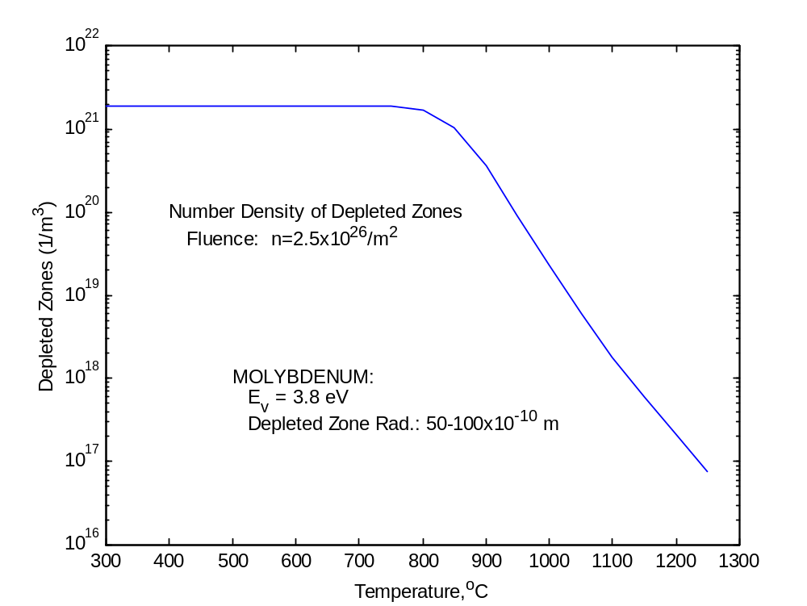
Figure 18: Calculated number density of depleted zones in Molybdenum as a function of temperature.
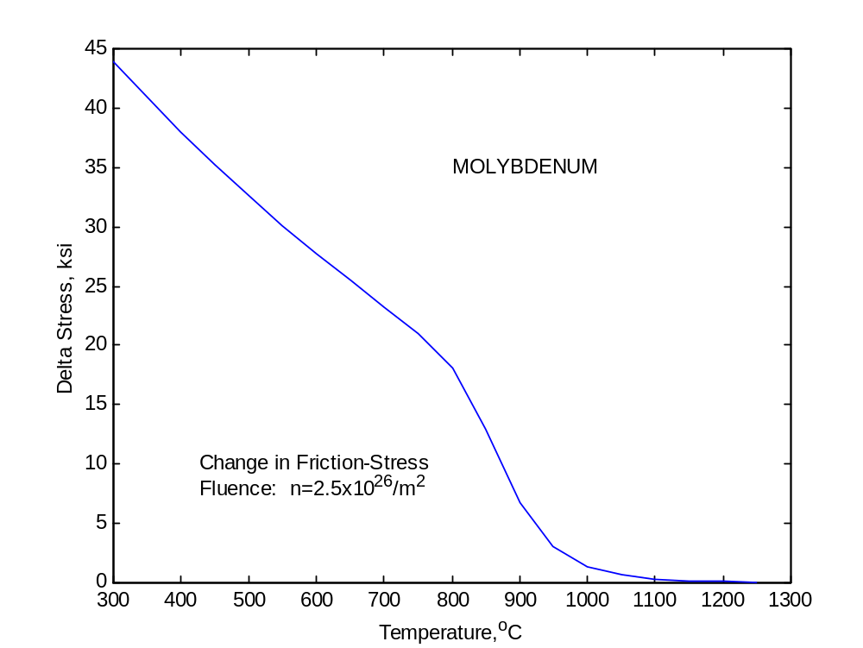
Figure 19: Calculated change in friction stress (σ_{s}) in Molybdenum as a function of temperature.
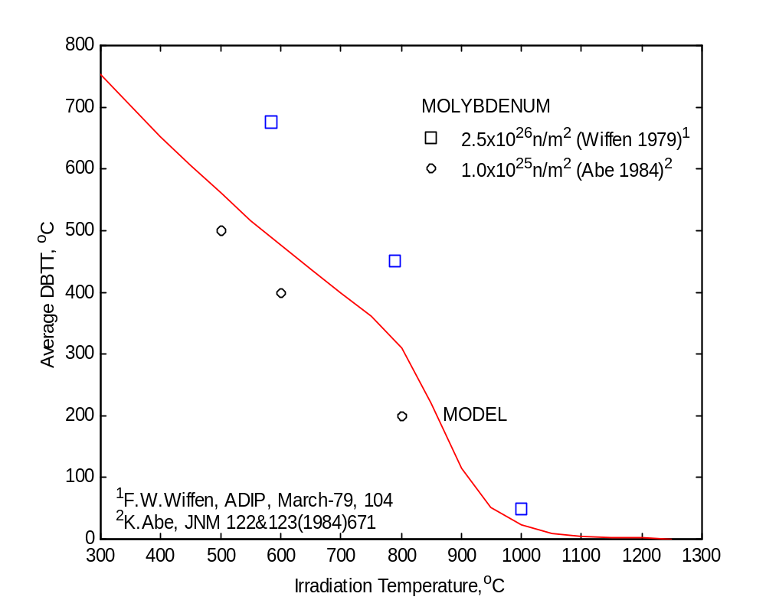
Figure 20: Calculated (solid line) and experimental (data points) Values of the Average DBTT of Recrystallized and of Neutron Irradiated Molybdenum as a Function of Temperature.
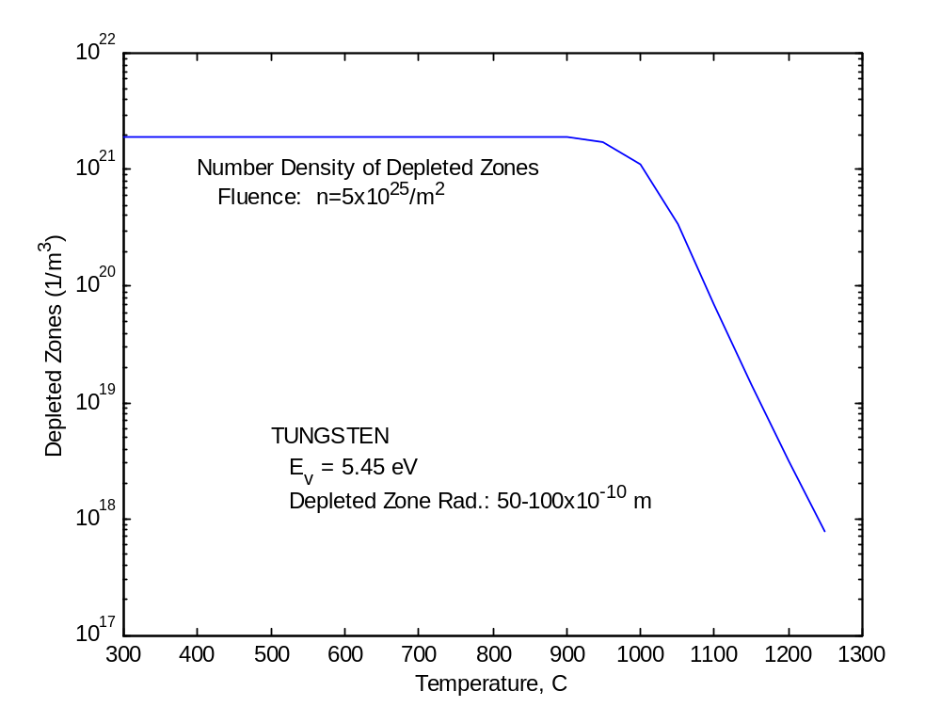
Figure 21: Calculated number density of depleted zones in Tungsten as a function of temperature.
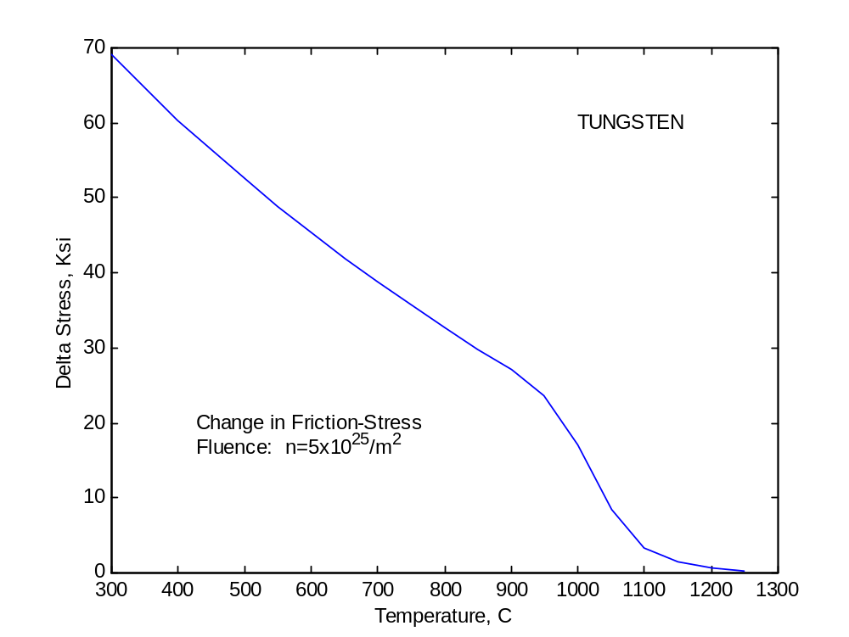
Figure 22: Calculated change in friction stress (σ_{s}) in Tungsten as a function of temperature.
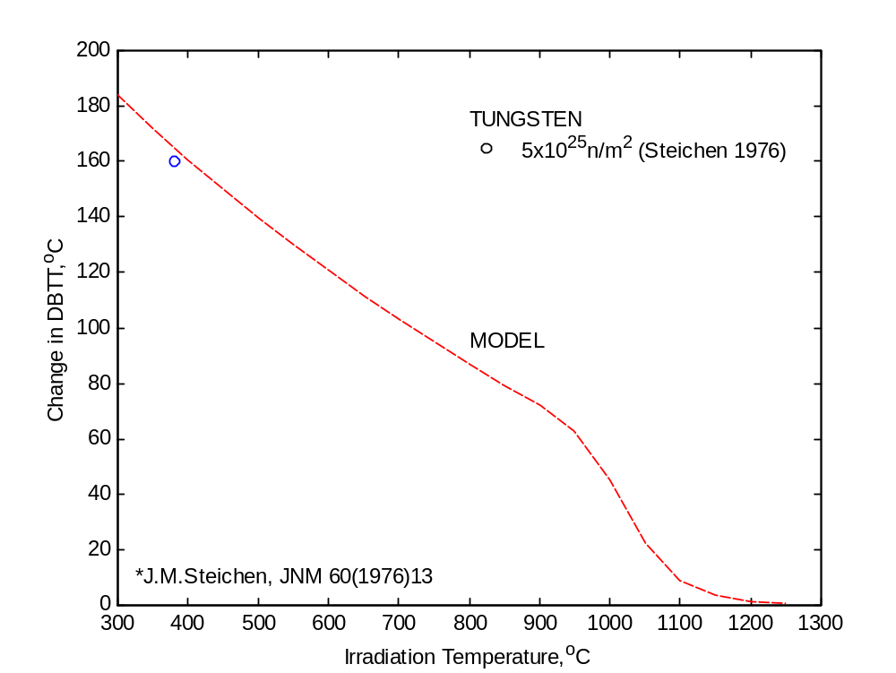
Figure 22: Calculated (solid line) and experimental (data point) Value of the Average DBTT of f Neutron Irradiated Tungsten as a Function of Temperature.

